|  |  |  |
| --- | --- | --- |
|  |  | |
|  | | |
|  | |  |
|  | | |
| Huawei FusionDirector for vROps Plug-in | |  |
| **User Guide** | |  |
|  | | |
| V1.0.17 | |  |
|  | | |
| Issue:02  Date:2021-01-27 | |  |
|  | | |
|  | Copyright © Copyright Holder. All rights reserved. | |

|  |  |  |  |
| --- | --- | --- | --- |
|  |  | | |
|  | | | |
|  | **Notice** |  | |
|  | The information in this document is subject to change without notice. Every effort has been made in the preparation of this document to ensure accuracy of the contents, but all statements, information, and recommendations in this document do not constitute the warranty of any kind, express or implied. |  |

Contents

About this Document 1

1 Overview 1-1

2 Managing the vROps Plug-in 2-1

2.1 Installation 2-1

2.2 Uninstallation 2-4

2.3 Upgrade 2-4

3 Setting the FusionDirector 3-1

3.1 Addition 3-1

3.2 Modification 3-11

3.3 Deletion 3-13

4 Querying Server Information 4-1

4.1 Querying Servers 4-1

4.2 Querying Component Information 4-3

4.3 Querying Component Group Information 4-5

4.4 Querying Server Information 4-6

4.5 Querying Server Type Information 4-7

4.6 Querying the FusionDirector Information 4-8

5 Querying Enclosure Information 5-1

5.1 Querying Enclosures 5-1

5.2 Querying Component Information 5-2

5.3 Querying Component Group Information 5-4

5.4 Querying Enclosure Information 5-5

5.5 Querying the FusionDirector Information 5-6

6 Querying Dashboard Information 6-1

6.1 Querying the FusionDirector Overview Dashboard 6-1

6.2 Querying Huawei Servers Overview Dashboard 6-1

6.3 Querying Huawei Server Detailed Dashboard 6-5

6.4 Querying Huawei Enclosure Overview Dashboard 6-6

6.5 Querying Huawei Enclosure Detailed Dashboard 6-7

7 Viewing Alerts 7-1

8 Querying the Huawei vROps Plug-in Version 8-1

A Getting Help 1

A.1 Collecting Fault Information 1

A.2 Preparing for Debugging 1

A.3 Using Product Documentation 1

A.4 Obtaining Technical Support 1

About this Document

Overview

This guide describes how to install and maintain Huawei vRealize Operations Manager (vROps) plug-in.

Intended Audience

This guide is intended for:

* Technical support engineers
* System maintenance engineers

Symbol Conventions

The symbols that may be found in this document are defined as follows.

| Symbol | Description |
| --- | --- |
|  | Indicates an imminently hazardous situation which, if not avoided, will result in death or serious injury. |
|  | Indicates a potentially hazardous situation which, if not avoided, could result in death or serious injury. |
|  | Indicates a potentially hazardous situation which, if not avoided, may result in minor or moderate injury. |
|  | Indicates a potentially hazardous situation which, if not avoided, could result in equipment damage, data loss, performance deterioration, or unanticipated results.  NOTICE is used to address practices not related to personal injury. |
|  | Calls attention to important information, best practices, and tips.  NOTE is used to address information not related to personal injury, equipment damage, and environment deterioration. |

Change History

Changes between document issues are cumulative. The latest document issue contains all the changes made in earlier issues.

| Issue | Date | Description |
| --- | --- | --- |
| 02 | 2021-01-27 | Updated 1 Overview. |
| 01 | 2019-05-15 | The issue is the first official release. |

# Overview

Function Description

Huawei FusionDirector for vRealize Operations Manager (vROps) plug-in can be used to manage and monitor Huawei servers. Only the vROps 6.5, 6.6, 6.7, and 7.0 versions are supported. The vROps UI varies according to its version. This document uses the vROps 6.7 as an example.

Huawei FusionDirector for vROps plug-in provides the following functions:

* Query the basic information about severs and enclosures (also referred to as chassis).
* Query the alert information about severs and enclosures.
* Query the health status of severs and enclosures.
* Query statistics about the FusionDirector, severs, and enclosures using the dashboard.

Supported Servers

Table 1-1 lists servers supported by Huawei FusionDirector for vROps plug-in.

Supported servers

| Type | Server |
| --- | --- |
| Rack | 1288H V5 |
| 2288H V5 |
| 2488 V5 |
| 2488H V5 |
| 8100 V5 |
| RH2288H V3 |
| Blade | CH121 V5 |
| CH242 V5 |
| CH121 V3 |
| CH242 V3 |
| Chassis | E9000 (MM920) |

# Managing the vROps Plug-in

2.1 Installation

2.2 Uninstallation

2.3 Upgrade

## Installation

Access [GitHub](https://github.com/Huawei/Huawei_FusionDirector_For_vROps/tree/master/release) and download the latest vROps installation package, such as **Huawei_FusionDirector_For_vROps_X.X.X.zip**.

Decompress the installation package.

Obtain the installer, such as **HuaweiFusionDirectorManagementPack_X.X.X.pak**.

On the vROps WebUI, choose **Administration**.

The **Administration** page is displayed.

In the navigation pane, choose **Solutions**.

The **Solutions** page is displayed.

Click .



The **Add Solution** dialog box is displayed, as shown in Figure 2-1.

Selecting a solution

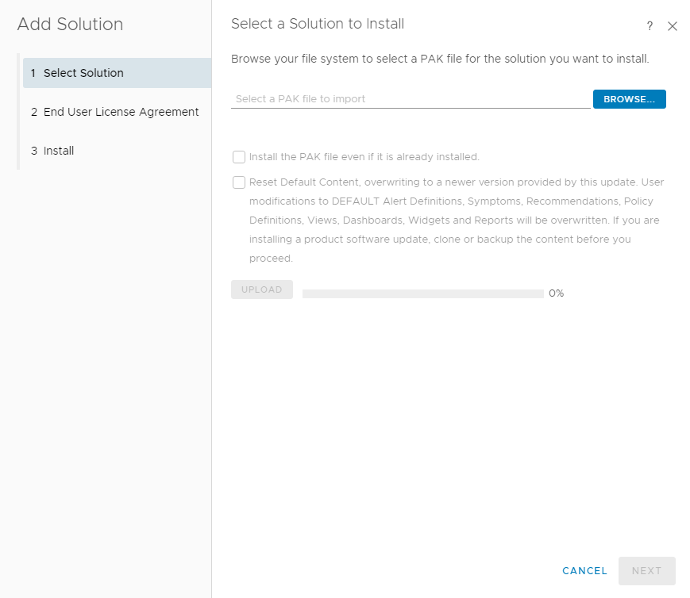

Click the **Select Solution** tab.

Click **BROWSE** and select the installation package.

(Optional) Select **Install the PAK file even if it is already installed**.

Click **UPLOAD** and upload the installation file.

Click **NEXT**.

The **Confirmation** dialog box is displayed.

Click **Yes**.

The **End User License Agreement** page is displayed, as shown in Figure 2-2.

End User License Agreement

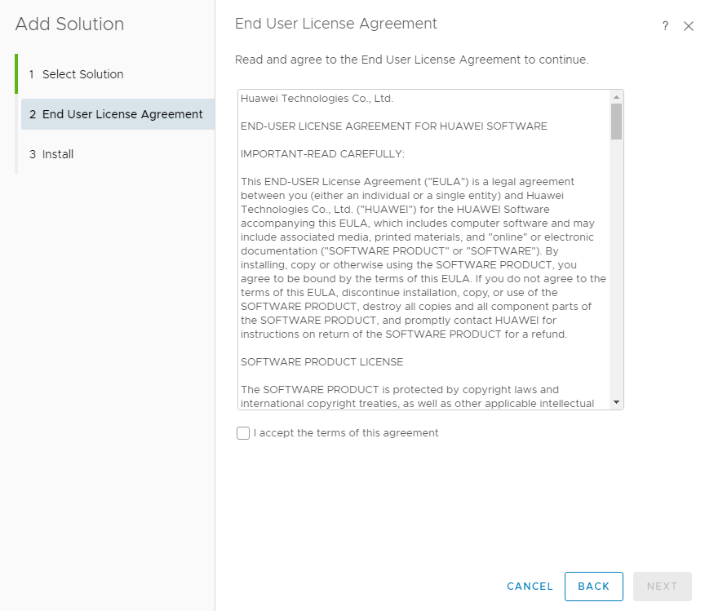

Select **I accept the terms of this agreement** and click **NEXT**.

The **Installation** page is displayed.

After the installation is complete, click **FINISH**.

Check the installed vROps on the **Solutions** page, as shown in Figure 2-3.

Viewing the vROps

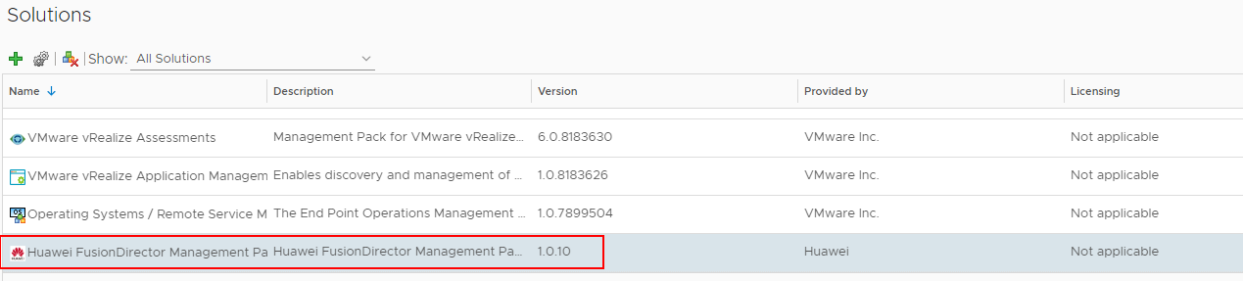

----End

## Uninstallation

On the vROps WebUI, choose **Administration**.

The **Administration** page is displayed.

In the navigation pane, choose **Solutions**.

The **Solutions** page is displayed.

Select the vROps plug-in and click , as shown in Figure 2-4.



Uninstalling the vROps



The **Alerts** dialog box is displayed.



Only Huawei vROps 6.6 and later versions can be uninstalled.

Select **I understand the risk and agree.** and click **OK**.

Huawei vROps plug-in is uninstalled.

----End

## Upgrade

Procedure

(Optional) Uninstall Huawei vROps plug-in of the early version. For details, see 2.2 Uninstallation.

Install Huawei vROps plug-in of the late version. For details, see 2.1 Installation.

----End

# Setting the FusionDirector

3.1 Addition

3.2 Modification

3.3 Deletion

## Addition

On the vROps WebUI, choose **Administration**.

The **Administration** page is displayed.

In the navigation pane, choose **Solutions**.

The **Solutions** page is displayed.

Select the vROps plug-in and click .



The **Manage Solution - Huawei FusionDirector Management Pack** dialog box is displayed.

In the **Instance Settings** area, set the following parameters, as shown in Figure 3-1.

Instance settings

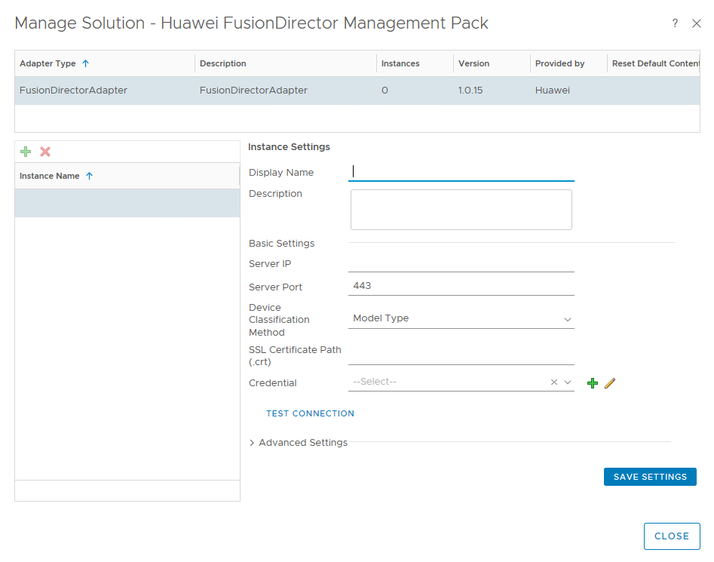

* **Display Name**: user-defined name to identify different FusionDirector instances
* **Description**: (optional) user-defined description to describe a FusionDirector instance
* **Server IP**: FusionDirector IP address
* **Server Port**: FusionDirector port number, which is **443** by default.
* **Device Classification Method**: way to classify servers
* **Model Type**: classify servers by type
* **Group Type**: classify servers by group
* **SSL Certificate Path(.crt)**: (optional) path of the certificate in the vROps



You are advised to upload the SSL certificate for security. For details about how to upload the certificate, see Step 5 to Step 6.

(Optional) Obtain the certificate.

1. Access the FusionDirector WebUI.
2. Click **Certificate error** in the address box of the browser.

The **Certificate Invalid** dialog box is displayed, as shown in Figure 3-2.

Invalid certificate

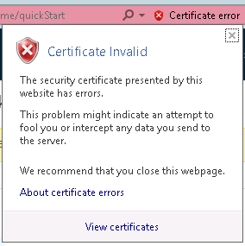

1. Click **View certificates**.

The **Certificate** dialog box is displayed.

1. Click the **Details** tab.

The **Details** tab is displayed, as shown in Figure 3-3.

Details

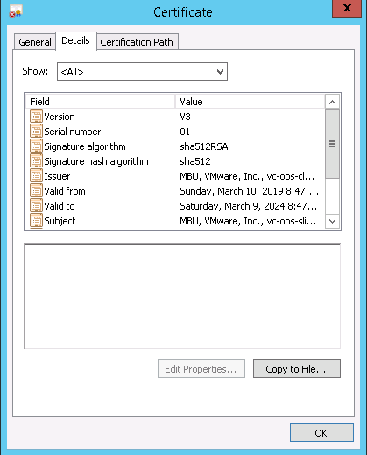

1. Click **Copy to File...**.

The **Certificate Export Wizard** is displayed, as shown in Figure 3-4.

Certificate Export Wizard

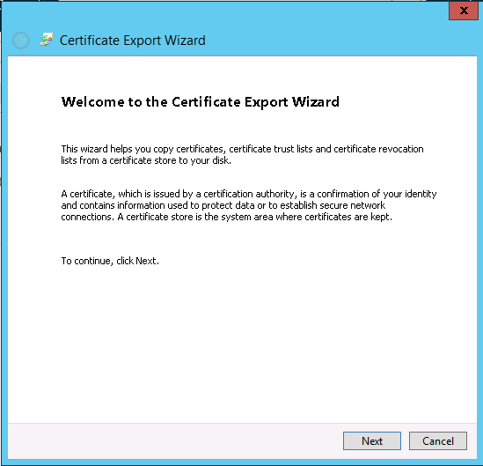

1. Click **Next**. In the **Certificate Export Wizard** dialog box, select **DER encoding binary X.509 (.CER)**, as shown in Figure 3-5.

Setting the format of files to be exported

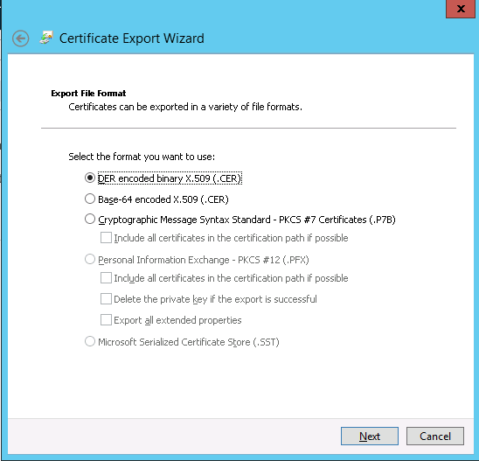

1. Click **Next**. In the **Certificate Export Wizard** dialog box, click **Browse...**, select the certificate export path, and enter the certificate file name, as shown in Figure 3-6.

Service certificate

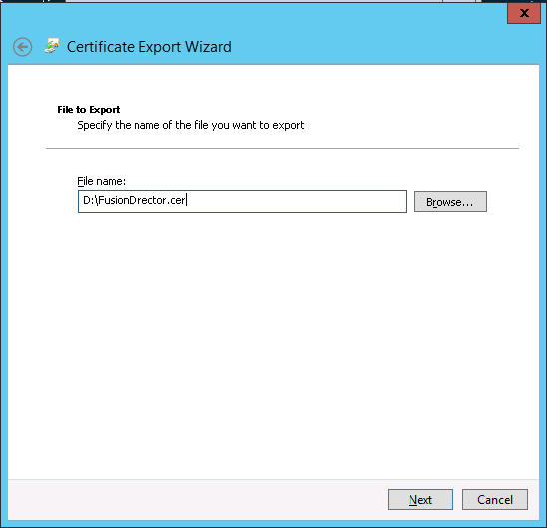

1. Click **Next** to complete certificate export.

(Optional) Import the certificate file to the vROps backend.

1. Configure the SSH access permission for the vROps.
   1. The vROps backend is displayed, as shown in Figure 3-7.

vROps backend

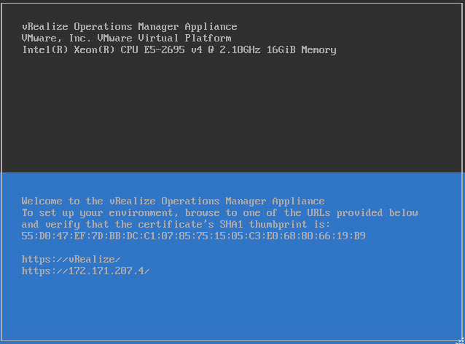

* 1. Press **Alt+F1** and enter the username and password to log in to the vROps, as shown in Figure 3-8.



* The username is **root** and the initial password is blank.
* When you log in for the first time, you need to change the initial password, press **Enter**, enter previous and new passwords, and confirm the new password. The new password must contain uppercase letters, lowercase letters, digits, and special characters.

Logging in to the vROps

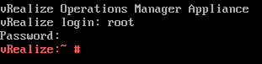

* 1. Run the **vi /etc/ssh/sshd_config** command to edit the configuration file **sshd_config**.

Change the value of **MaxSession** to **20** and the value of **AllowTcpForwarding** to **yes**.

* 1. Run the **service sshd start** command to start the SSHD service.
  2. Run the **chkconfig sshd on** command to enable the SSHD service.
  3. Run the **service vmware-vcops-firewall stop** command to disable the firewall.
  4. Run the **chkconfig vmware-vcops-firewall off** command to disable the firewall upon startup.

1. Use the SSH tool to upload the certificate file to **/usr/lib/vmware-vcops/user/plugins/inbound**.
2. Enter the SSL certificate path **/usr/lib/vmware-vcops/user/plugins/inbound/FusionDirector.crt** in Step 4.

In the **Credential** field, click .



The **Manage Credentials** dialog box is displayed.

Set the following parameters and click **OK**, as shown in Figure 3-9.

Managing credentials

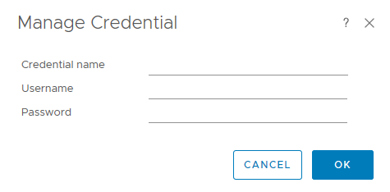

* **Credential name**: user-defined name to identify different credentials
* **Username**: FusionDirector username to access the Redfish API. The default username is **rootRedfish**.
* **Password**: FusionDirector password to access the Redfish API. The default password is **Machine@123**.

Click **TEST CONNECTION**.

If the test connection is successful, a dialog box is displayed, as shown in Figure 3-10. Click **OK**. If the test connection fails, the failure cause is displayed. Modify the FusionDirector information as prompted.

Successful test connection

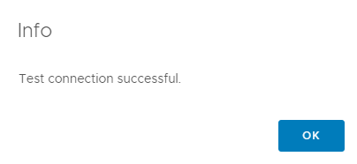

Click **SAVE SETTINGS**.

The dialog box is displayed indicating that the settings are successfully saved, as shown in Figure 3-11.

Successfully saving settings

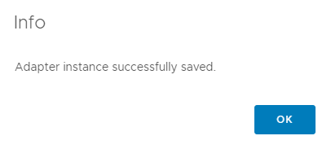

Click **OK**.

The FusionDirector instance is added.

Click **CLOSE**.

On the **Solutions** page, view the data collected by the FusionDirector instance, as shown in Figure 3-12.

Solutions

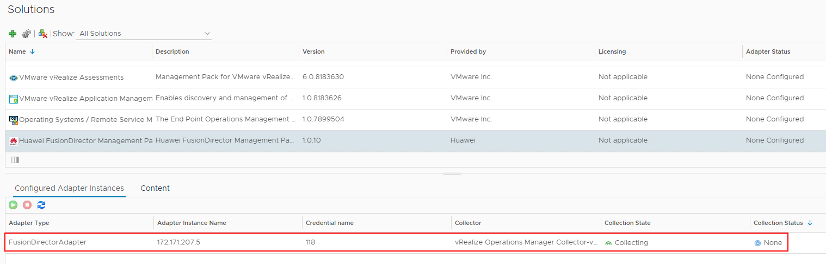

----End

## Modification

On the vROps WebUI, choose **Administration**.

The **Administration** page is displayed.

In the navigation pane, choose **Solutions**.

The **Solutions** page is displayed.

Select the vROps plug-in and click .



The **Manage Solution - Huawei FusionDirector Management Pack** dialog box is displayed.

In the navigation pane, select a FusionDirector instance to be modified and set the following parameters, as shown in Figure 3-13.

Modifying the FusionDirector instance

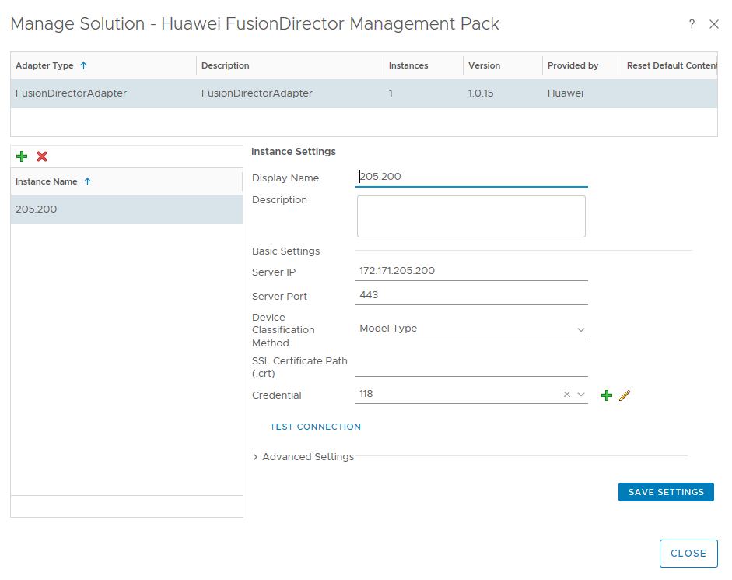

* **Display name**: user-defined name to identify different FusionDirector instances
* **Description**: (optional) user-defined description to describe a FusionDirector instance
* **Server IP**: FusionDirector IP address
* **Server Port**: FusionDirector port number, which is **443** by default.
* **Device Classification Method**: way to classify servers
* **Model Type**: classify servers by type
* **Group Type**: classify servers by group
* **SSL Certificate Path(.crt)**: (optional) path of the certificate in the vROps
* **Credential**: Click to change the credential name, username, and password.



If the FusionDirector port number, username, or password is changed after the FusionDirector connection, you need to synchronize the new port number, user name, or password to the FusionDirector. Otherwise, server management is affected.

Check whether basic settings of the instance are modified.

* Click **TEST CONNECTION**. After test connection is successful, click **SAVE SETTINGS**.
* If failed, click **SAVE SETTINGS**.

The dialog box is displayed indicating that the settings are successfully saved, as shown in Figure 3-14.

Successfully saving settings



Click **OK**.

The FusionDirector instance is modified.

Click **CLOSE**.

On the **Solutions** page, view the data collected by the FusionDirector instance after modification, as shown in Figure 3-15.

Collecting data

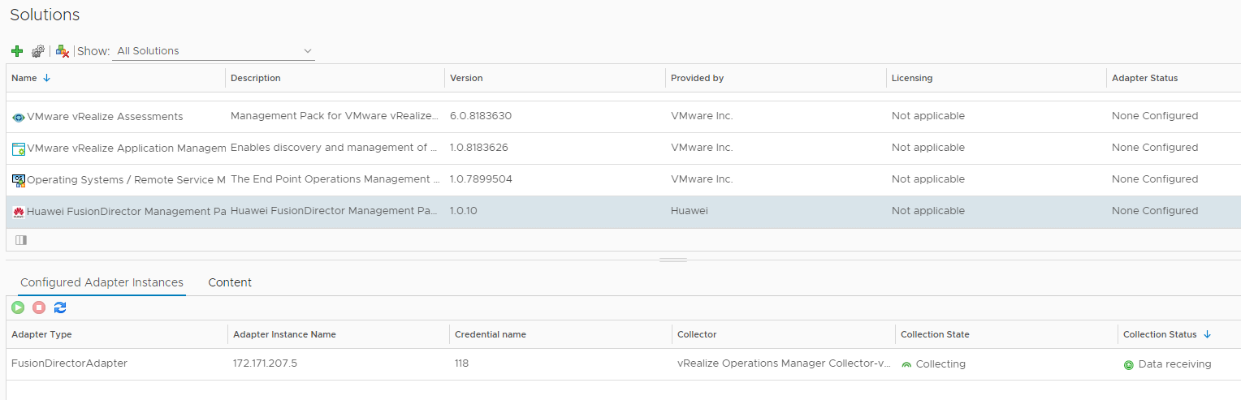

----End

## Deletion

On the vROps WebUI, choose **Administration**.

The **Administration** page is displayed.

In the navigation pane, choose **Solutions**.

The **Solutions** page is displayed.

Select the vROps plug-in and click .



The **Manage Solution - Huawei FusionDirector Management** **Pack** dialog box is displayed.

In the navigation pane, select the FusionDirector instance to be deleted and click , as shown in Figure 3-16.



Managing solutions

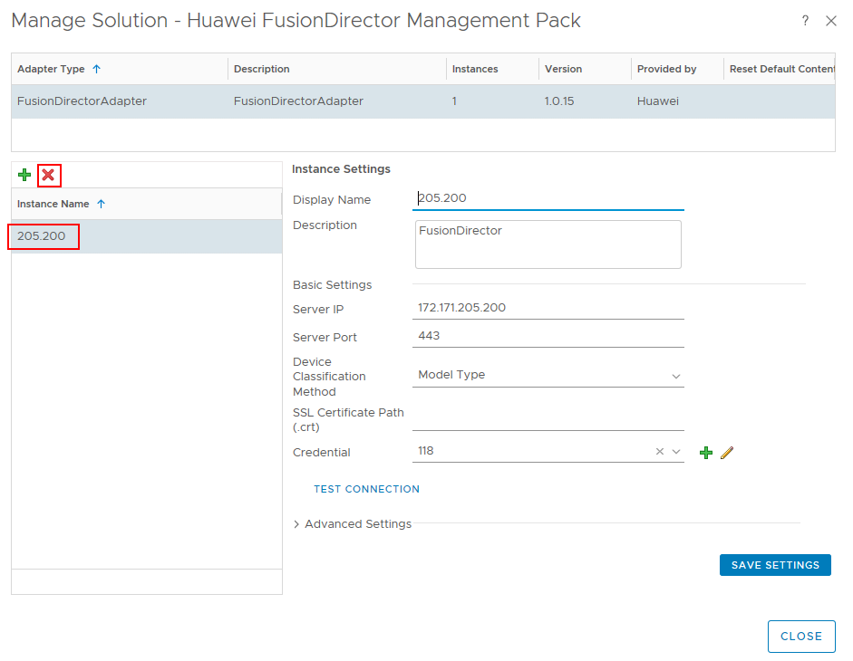

The **Confirmation** dialog box is displayed.

Select **Remove related objects.** (which is selected by default) and click **YES**.

The FusionDirector instance is deleted.

----End

# Querying Server Information

4.1 Querying Servers

4.2 Querying Component Information

4.3 Querying Component Group Information

4.4 Querying Server Information

4.5 Querying Server Type Information

4.6 Querying the FusionDirector Information

## Querying Servers

On the vROps WebUI, choose **Environment**.

The **Environment** page is displayed.

In the navigation pane, choose **Huawei FusionDirector Management Pack** > **Huawei Servers**.

The **Huawei Servers** page is displayed.

In the navigation pane, view the list of all servers, as shown in Figure 4-1 and Figure 4-2.

Huawei servers by Model Type

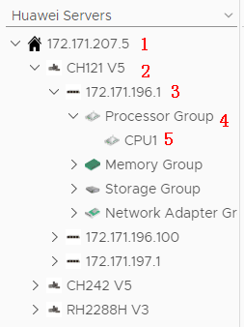

* 1: FusionDirector IP address
* 2: Server model
* 3: Server label and BMC IP address. If no label is set for the server, only the BMC IP address is displayed. For details about how to set the server label, see [FusionDirector User Guide](https://support.huawei.com/enterprise/zh/doc/EDOC1100044448).
* 4: Component group
* 5: A component

Huawei servers by Group Type

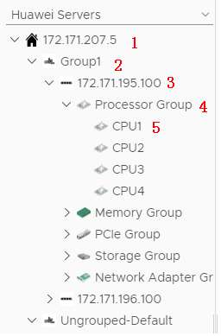

* 1: FusionDirector IP address
* 2: Server group name, which can be set in the FusionDirector. For details, see [FusionDirector User Guide](https://support.huawei.com/enterprise/zh/doc/EDOC1100044448).
* 3: Server label and BMC IP address. If no label is set for the server, only the BMC IP address is displayed. For details about how to set the server label, see [FusionDirector User Guide](https://support.huawei.com/enterprise/zh/doc/EDOC1100044448).
* 4: Component type
* 5: A component

----End

## Querying Component Information

On the vROps WebUI, select **Environment**.

The **Environment** page is displayed.

In the navigation pane, choose **Huawei FusionDirector Management Pack** > **Huawei Servers**.

The **Huawei Servers** page is displayed.

Select a FusionDirector IP address, a server model (by Group Type), a server, a component group, and a component, as shown in Figure 4-3.

Component information

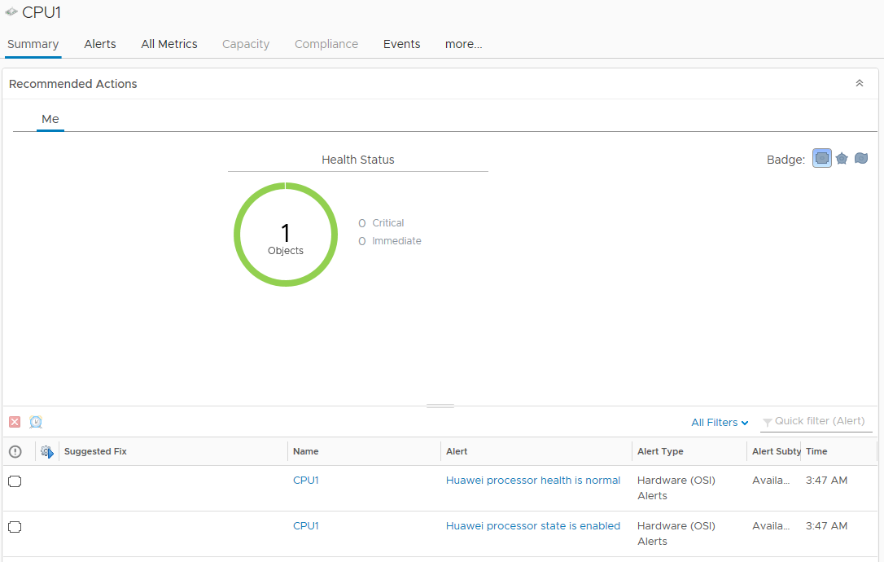

Click **Summary**.

The **Summary** page is displayed. View the running status of the component in the **Recommended Actions** area, as shown in Figure 4-4.

Summary



Click the **Alerts** tab.

On the **Alerts** tab page, click an alert to view its details, as shown in Figure 4-5.

Alerts

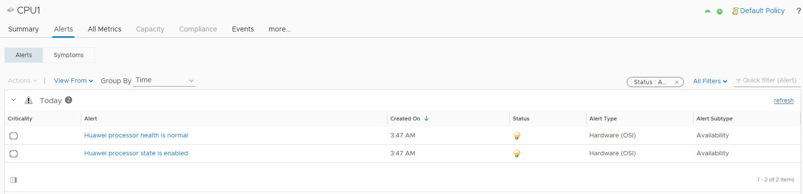

Click **more** > **Details**.

On the **Details** tab page, select a view to view its details, as shown in Figure 4-6.

Details

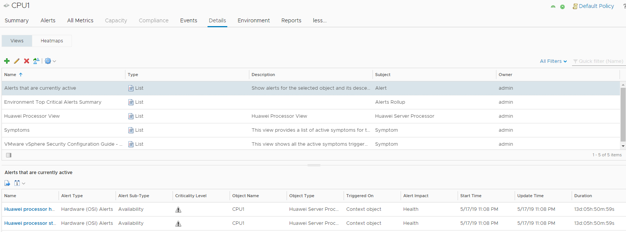

----End

## Querying Component Group Information

On the vROps WebUI, choose **Environment**.

The **Environment** page is displayed.

In the navigation pane, choose **Huawei FusionDirector Management Pack** > **Huawei Servers**.

The **Huawei Servers** page is displayed.

Select a FusionDirector IP address, a server model (by **Group Type**), a server, and a component group, as shown in Figure 4-7.

See 4.2 Querying Component Information to view the summary, alerts, and details of all components in the component group.

Component group information

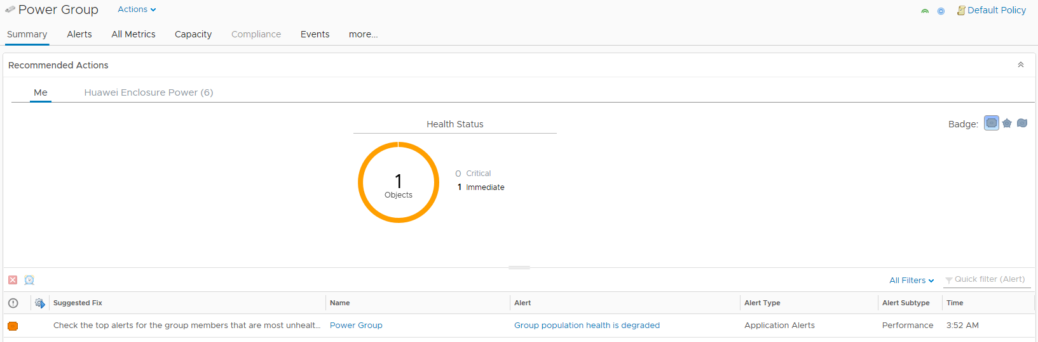

----End

## Querying Server Information

On the vROps WebUI, choose **Environment**.

The **Environment** page is displayed.

In the navigation pane, choose **Huawei FusionDirector Management Pack** > **Huawei Servers**.

The **Huawei Servers** page is displayed.

Select a FusionDirector IP address, a server model (by **Group Type**), and a server, as shown in Figure 4-8.

See 4.2 Querying Component Information to view the summary, alerts, and details of all components on a server.

Server information

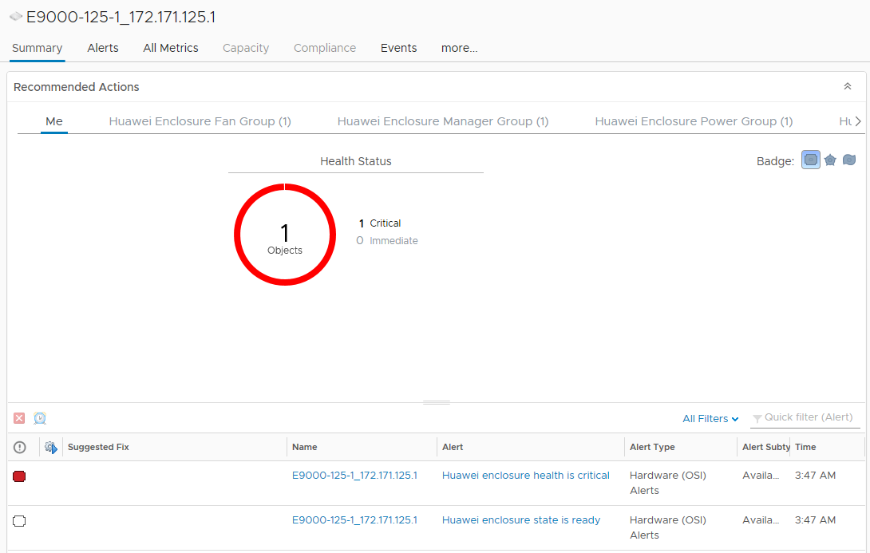

----End

## Querying Server Type Information

On the vROps WebUI, choose **Environment**.

The **Environment** page is displayed.

In the navigation pane, choose **Huawei FusionDirector Management Pack** > **Huawei Servers**.

The **Huawei Servers** page is displayed.

Select a FusionDirector IP address and a server model (by Group Type), as shown in Figure 4-9.

See 4.2 Querying Component Information to view the summary, alerts, and details of all components of one server type.

Server type

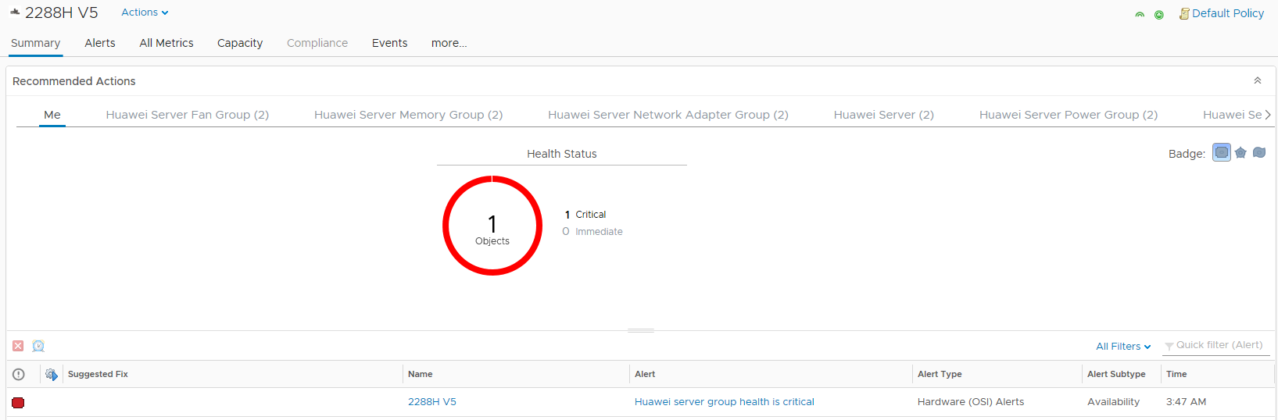

----End

## Querying the FusionDirector Information

On the vROps WebUI, choose **Environment**.

The **Environment** page is displayed.

In the navigation pane, choose **Huawei FusionDirector Management Pack** > **Huawei Servers**.

The **Huawei Servers** page is displayed.

Select a FusionDirector IP address, as shown in Figure 4-10.

See 4.2 Querying Component Information to view the summary, alerts, and details of all components in the FusionDirector.

FusionDirector information

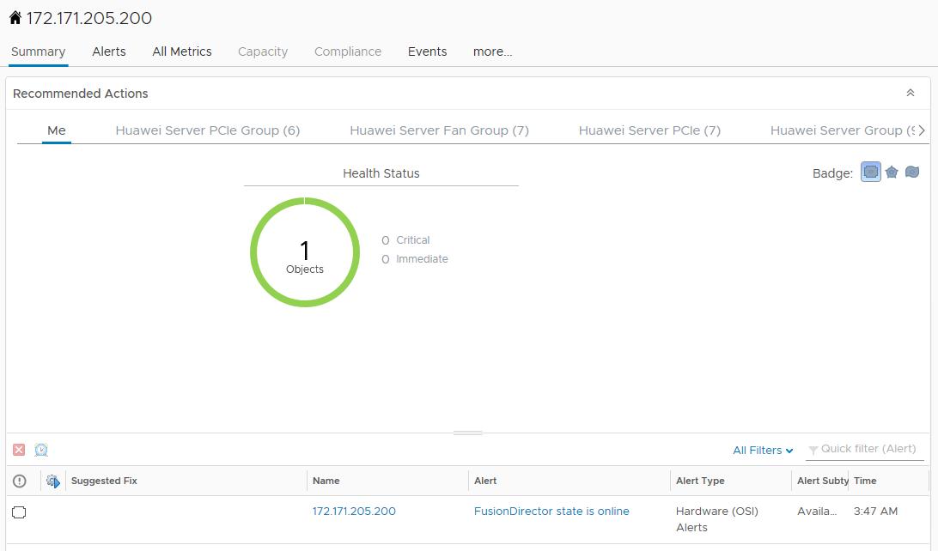

----End

# Querying Enclosure Information

5.1 Querying Enclosures

5.2 Querying Component Information

5.3 Querying Component Group Information

5.4 Querying Enclosure Information

5.5 Querying the FusionDirector Information

## Querying Enclosures

On the vROps WebUI, choose **Environment**.

The **Environment** page is displayed.

In the navigation pane, choose **Huawei FusionDirector Management Pack** > **Huawei Enclosures**.

The **Huawei Enclosures** page is displayed.

In the navigation pane, view the list of all enclosures, as shown in Figure 5-1.

Huawei enclosures

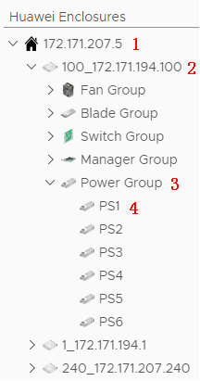

* 1: FusionDirector IP address
* 2: Enclosure name and BMC IP address
* 3: Component group
* 4: A component

----End

## Querying Component Information

On the vROps WebUI, choose **Environment**.

The **Environment** page is displayed.

In the navigation pane, choose **Huawei FusionDirector Management Pack** > **Huawei Enclosures**.

The **Huawei Enclosures** page is displayed.

Select a FusionDirector IP address, an enclosure, a component group, and a component, as shown in Figure 5-2.

Component information

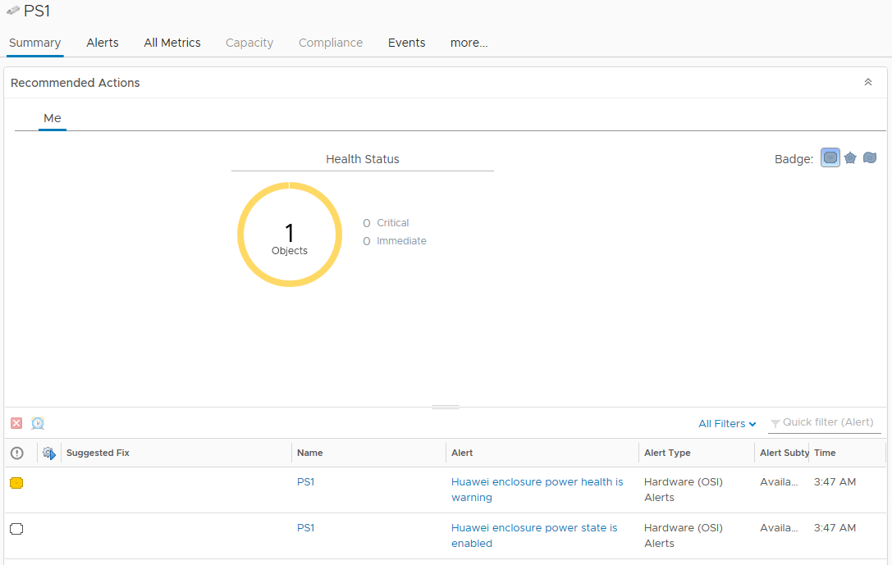

Click **Summary**.

The **Summary** page is displayed. View the running status of the component in the **Recommended Actions** area, as shown in Figure 5-3.

Summary



Click the **Alerts** tab.

On the **Alerts** tab page, click an alert to view its details, as shown in Figure 5-4.

Alerts

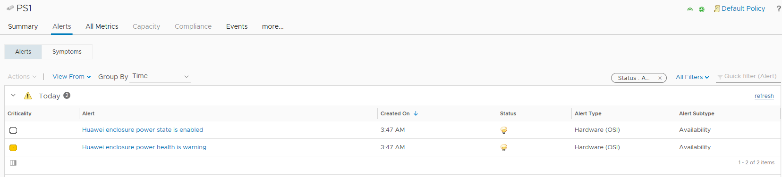

Click **more** > **Details**.

On the **Details** tab page, select a view to view its details, as shown in Figure 5-5.

Details

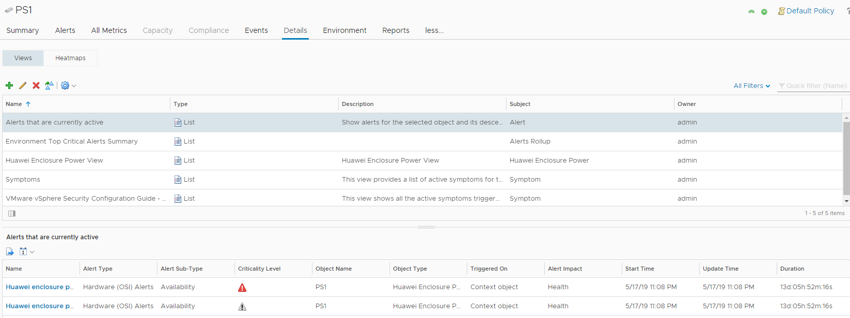

----End

## Querying Component Group Information

On the vROps WebUI, choose **Environment**.

The **Environment** page is displayed.

In the navigation pane, choose **Huawei FusionDirector Management Pack** > **Huawei Enclosures**.

The **Huawei Enclosures** page is displayed.

Select a FusionDirector IP address, an enclosure, and a component group, as shown in Figure 5-6.

See 5.2 Querying Component Information to view the summary, alerts, and details of all components in the component group.

Component information



----End

## Querying Enclosure Information

On the vROps WebUI, choose **Environment**.

The **Environment** page is displayed.

In the navigation pane, choose **Huawei FusionDirector Management Pack** > **Huawei Enclosures**.

The **Huawei Enclosures** page is displayed.

Select a FusionDirector IP address and an enclosure, as shown in Figure 5-7.

See 5.2 Querying Component Information to view the summary, alerts, and details of all components using the enclosure.

Enclosure information



----End

## Querying the FusionDirector Information

On the vROps WebUI, choose **Environment**.

The **Environment** page is displayed.

In the navigation pane, choose **Huawei FusionDirector Management Pack** > **Huawei Enclosures**.

The **Huawei Enclosures** page is displayed.

Select a FusionDirector IP address, as shown in Figure 5-8.

See 5.2 Querying Component Information to view the summary, alerts, and details of all components in the FusionDirector.

FusionDirector information

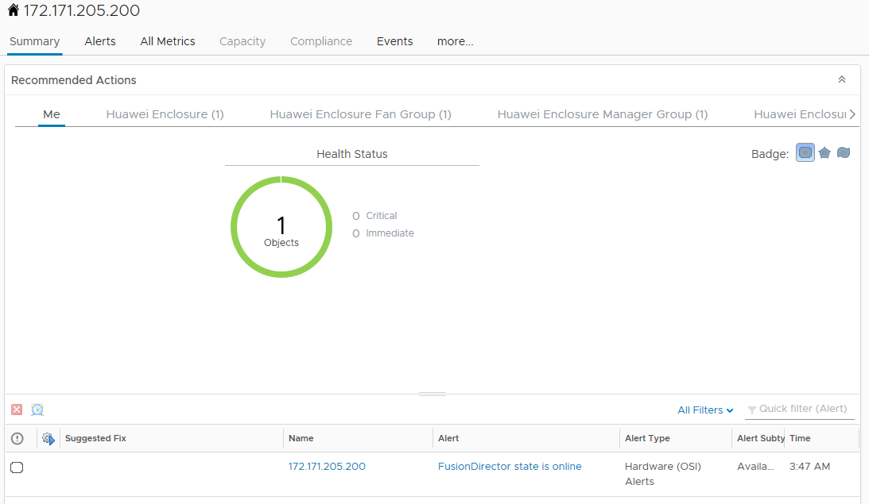

----End

# Querying Dashboard Information

6.1 Querying the FusionDirector Overview Dashboard

6.2 Querying Huawei Servers Overview Dashboard

6.3 Querying Huawei Server Detailed Dashboard

6.4 Querying Huawei Enclosure Overview Dashboard

6.5 Querying Huawei Enclosure Detailed Dashboard

## Querying the FusionDirector Overview Dashboard

On the vROps WebUI, choose **Dashboards**.

The **Dashboards** page is displayed.

In the navigation pane, choose **Dashboards** > **Fusion Director Overview Dashboard**.

The **Fusion Director Overview Dashboard** page is displayed.

You can view the FusionDirector name, adapter type, object type, policy, collection state, collection status, server IP address, port, state, FusionDirector version, and classification method, as shown in Figure 6-1.

FusionDirector Overview Dashboard

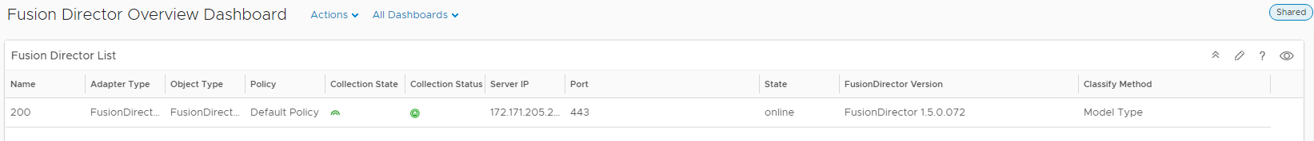

----End

## Querying Huawei Servers Overview Dashboard

On the vROps WebUI, choose **Dashboards**.

The **Dashboards** page is displayed.

In the navigation pane, choose **Dashboards** > **Huawei Servers Overview Dashboard**.

The **Huawei Servers Overview Dashboard** page is displayed.

You can view the following information, as shown in Figure 6-2.

* Servers Environment Health
* Servers Latest Alerts
* Top High Power Consumption Servers
* Top High Inlet Temperature Servers
* Top High Fan Speed On Average Servers
* Select About for Power Consumption Trend
* Select About for Temperature Trend
* Select About for Fan Speed Trend

Huawei Servers Overview Dashboard

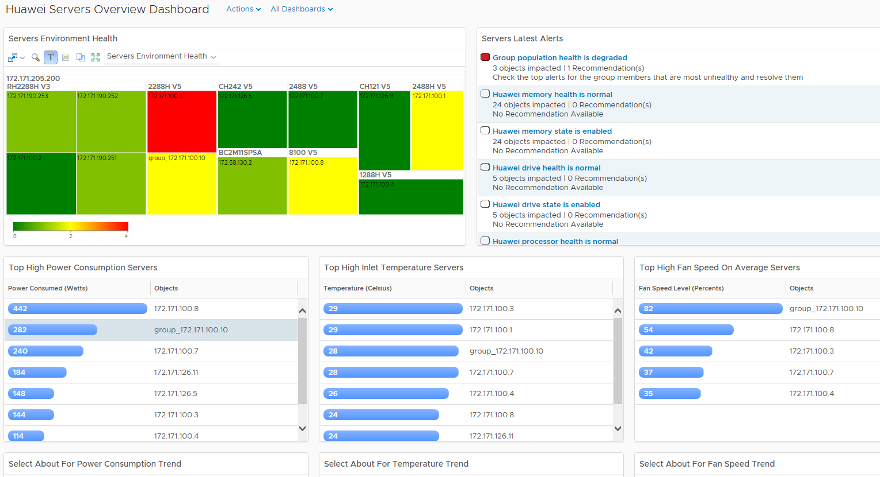

In the **Servers Environment Heath** area, select a server. You can view the latest alarms of the server in the **Servers Latest Alerts** area, as shown in Figure 6-3.

Huawei Servers Latest Alerts

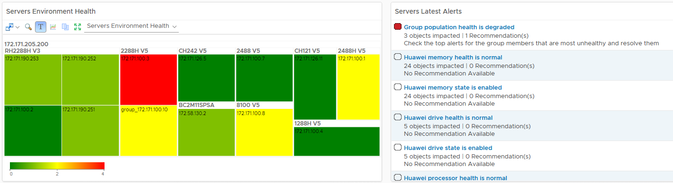

In the **Top High Power Consumption Servers** area, select different servers. You can view power consumption trends of these servers in the **Select About For Power Consumption Trend** area, as shown in Figure 6-4.

Power consumption trend

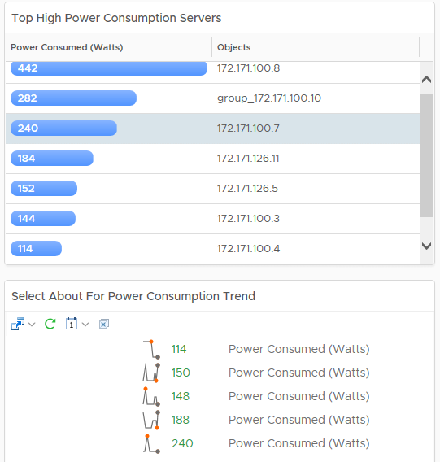

In the **Top High Inlet Temperature Servers** area, select different servers. You can view temperature trends of these servers in the **Select About For Temperature Trend** area, as shown in Figure 6-5.

Temperature trend

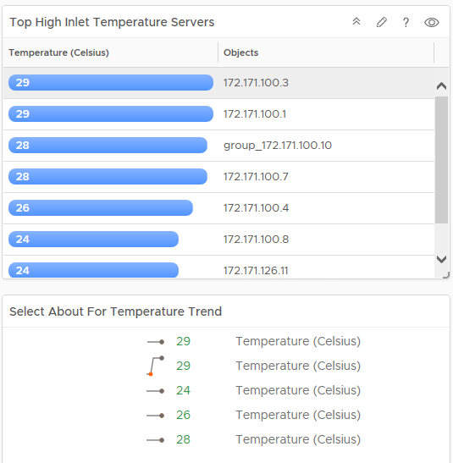

In the **Top High Fan Speed On Average Servers** area, select different servers. You can view fan speed trends of these servers in the **Select About For Fan Speed Trend** area, as shown in Figure 6-6.

Fan speed trend

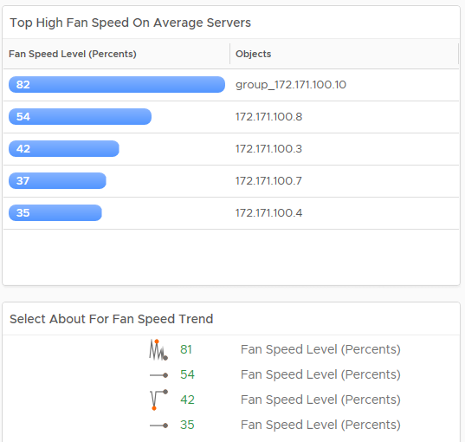

----End

## Querying Huawei Server Detailed Dashboard

On the vROps WebUI, choose **Dashboards**.

The **Dashboards** page is displayed.

In the navigation pane, choose **Dashboards** > **Huawei Server Detailed Dashboard**.

The **Huawei Server Detailed Dashboard** page is displayed.

In the **Huawei Server List** area, select the server to be viewed.

You can view the following information, as shown in Figure 6-7.

* Object Relationship
* Latest Alerts
* Huawei Server Power Consumption Metric Chart

Huawei Server Detailed Dashboard

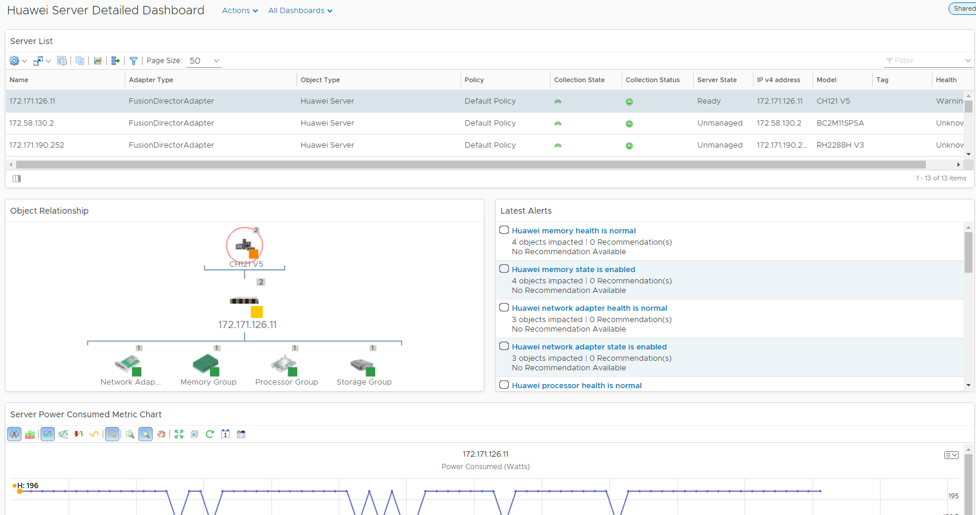

The server topology is displayed in the **Object Relationship** area. You can click any server to view the alerts and detailed information about the server, as shown in Figure 6-8.

Object Relationship

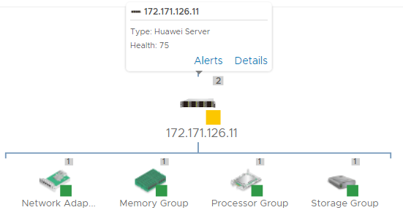

----End

## Querying Huawei Enclosure Overview Dashboard

On the vROps WebUI, choose **Dashboards**.

The **Dashboards** page is displayed.

In the navigation pane, choose **Dashboards** > **Huawei Enclosure Overview Dashboard**.

The **Huawei Enclosure Overview Dashboard** page is displayed.

You can view the following information, as shown in Figure 6-9.

* Enclosure Environment Health
* Enclosure Latest Alerts

Huawei Enclosure Overview Dashboard

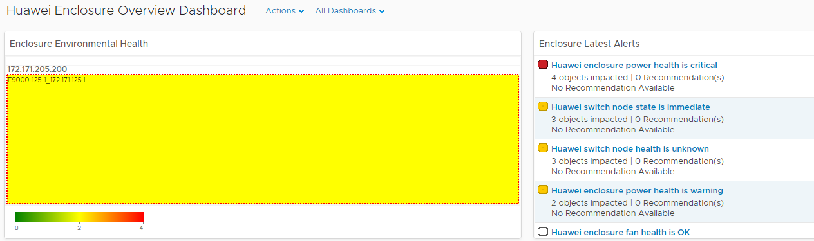

----End

## Querying Huawei Enclosure Detailed Dashboard

On the vROps WebUI, choose **Dashboards**.

The **Dashboards** page is displayed.

In the navigation pane, choose **Dashboards** > **Huawei Enclosure Detailed Dashboard**.

The **Huawei Enclosure Detailed Dashboard** page is displayed.

In the **Enclosure List** area, select the enclosure to be viewed.

You can view the following information, as shown in Figure 6-10.

* Latest Alerts
* Object Relationship

Huawei Enclosure Detailed Dashboard

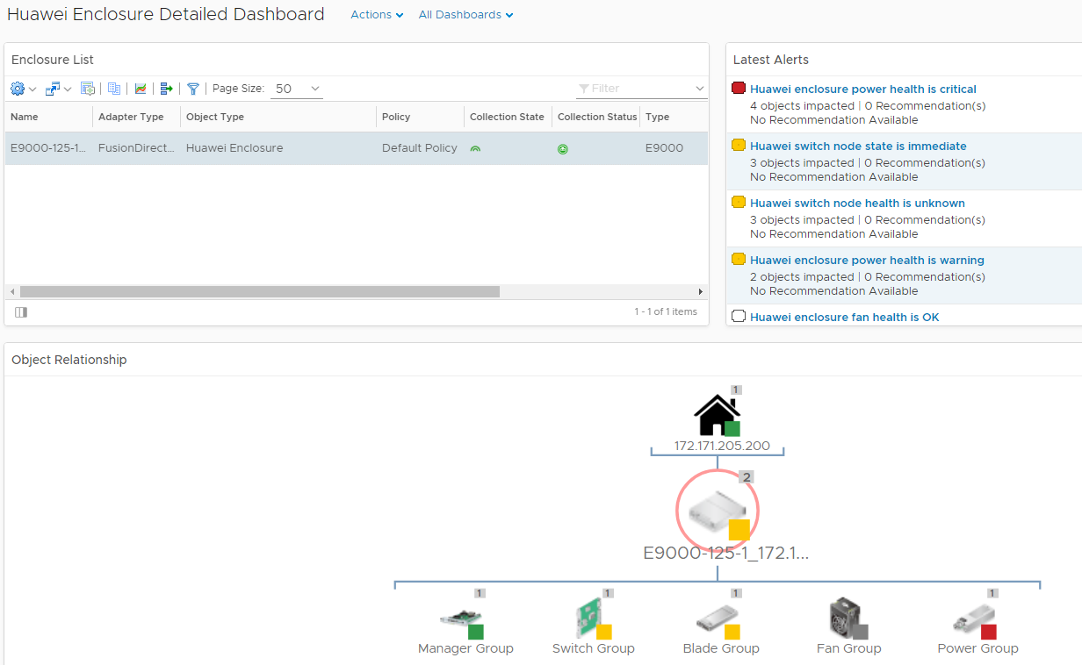

The enclosure topology is displayed in the **Object Relationship** area. You can click any enclosure or component to view the alerts and detailed information, as shown in Figure 6-11.

Object Relationship

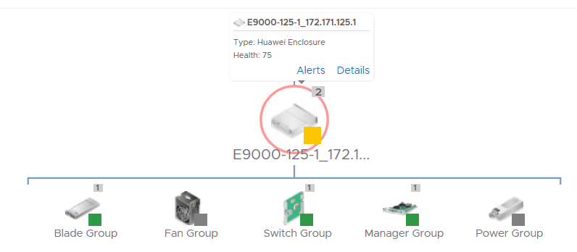

----End

# Viewing Alerts

On the vROps WebUI, choose **Alerts**.

The **Alerts** page is displayed.

In the navigation pane, choose **All Alerts**.

The **All Alerts** dialog box is displayed.

Select **Object Type** from the **Group By** drop-down list box.

In an alert row, click **Triggered On**, as shown in Figure 7-1.



You can only select a component, not a component group. Otherwise, the alerted server cannot be located.

All alerts

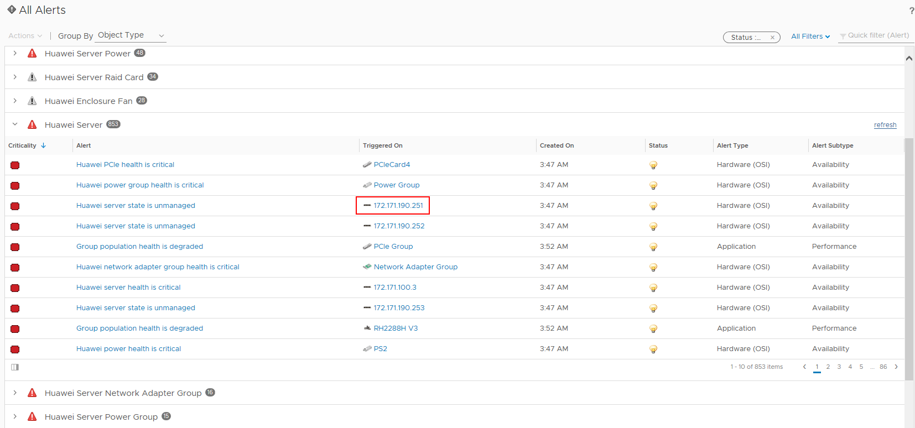

The page about the triggered object is displayed, as shown in Figure 7-2.

Triggered object

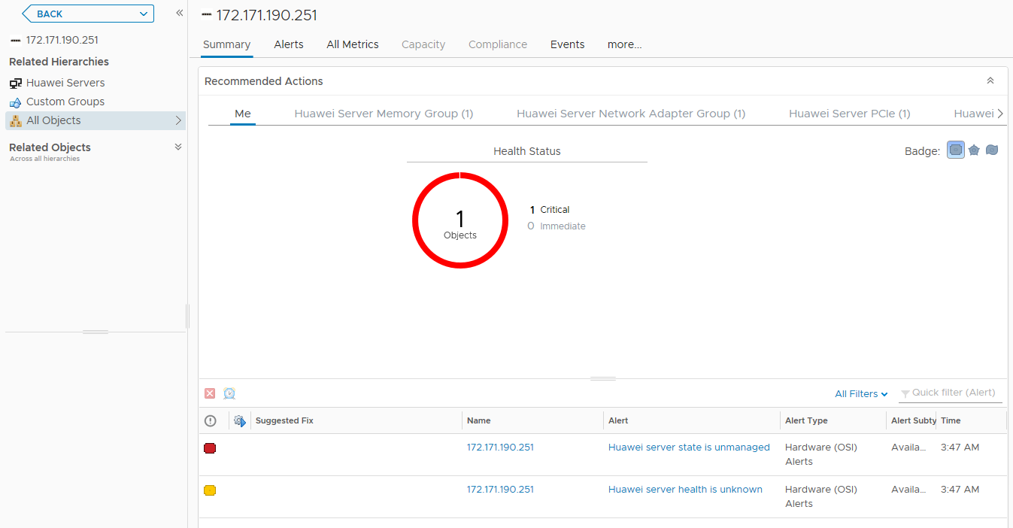

In the navigation pane, choose **All Objects**.

The **All Objects** page is displayed, as shown in Figure 7-3.

All objects

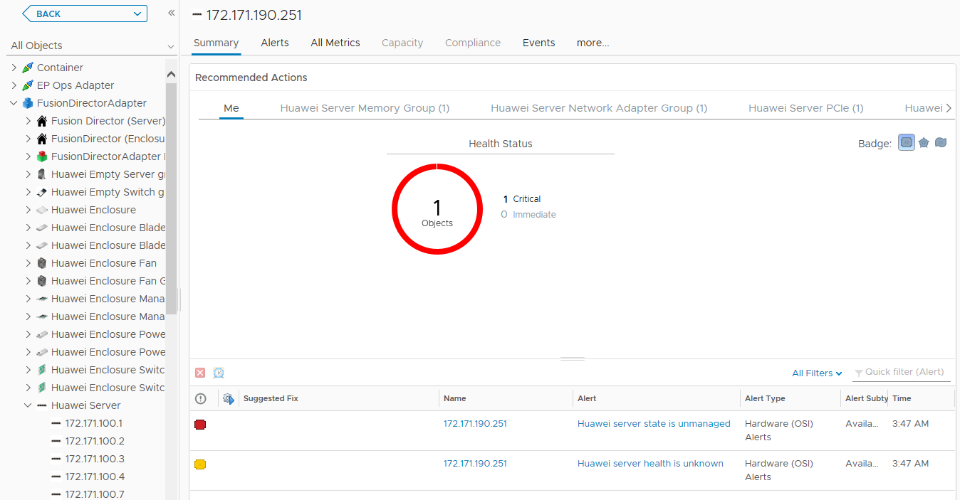

----End

# Querying the Huawei vROps Plug-in Version

On the vROps WebUI, choose **Administration**.

The **Administration** page is displayed.

In the navigation pane, choose **Solutions**.

The **Solutions** page is displayed.

Check the current version of the Huawei vROps plug-in, as shown in Figure 8-1.

Solutions

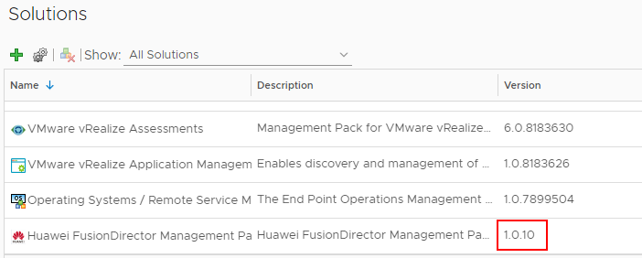

----End

1. Getting Help

If you encounter any problems during routine maintenance or troubleshooting, contact Huawei technical support engineers.

* 1. Collecting Fault Information

Before troubleshooting, obtain the following information:

* Customer company and address
* Contact person and telephone number
* Time when the fault occurred
* Detailed fault symptom
* Device type and software version
* Any measures taken and effects
* Fault severity and expected rectification deadline
  1. Preparing for Debugging

When you seek Huawei technical support, Huawei technical support engineers may assist you in performing some operations to further collect fault information or rectify the fault.

Before contacting technical support engineers, prepare the spare parts for boards and port modules, screwdrivers, screws, serial cables, and network cables.

* 1. Using Product Documentation

Huawei provides the documents delivered with the equipment. This document provides guidance for you to solve common problems that occur during routine maintenance or troubleshooting.

To better rectify the fault, you are advised to use the guide before contacting Huawei technical support engineers.

* 1. Obtaining Technical Support

Huawei's timely and efficient response is available from:

* Local branch offices
* Secondary technical support system
* Telephone support
* Remote support
* Onsite support

Technical Support Website

Obtain technical documents at [Huawei Technical Support](https://support.huawei.com/enterprise/en/index.html) website.

Self-Service Platform and Community

Learn more about servers and communicate with experts at:

* [Computing Product Information Service Platform](https://support-it.huawei.com/server/#/home) for specific server product documentation.
* [Huawei Enterprise iKnow](https://support.huawei.com/iknow/?source=SupportE) for quick learning about products.
* [Huawei Enterprise Support Community (Servers)](https://forum.huawei.com/enterprise/en/Server/forum/895) for learning and discussion.

News

For notices about product life cycles, warnings, and updates, visit [Support > Bulletins > Product Bulletins](https://support.huawei.com/enterprise/en/bulletins-product).

Cases

Learn about server applications at [Computing Case Library](https://support-it.huawei.com/server-knowledgebase/#/home).



The Computing Case Library is available only to Huawei partners and Huawei engineers.

Huawei Technical Support

If a fault persists after taking the above measures, obtain technical support in the following ways:

* Contact Huawei customer service center.
* Enterprise customers

Send emails to [support_e@huawei.com](mailto:support_e@huawei.com) or visit [Global Service Hotline](https://e.huawei.com/en/service-hotline-query).

* Carriers

Send emails to [support@huawei.com](mailto:support@huawei.com) or visit [Global TAC Information](https://support.huawei.com/carrier/docview!docview?nid=IN0000034614).

* Contact technical support at your local Huawei office.